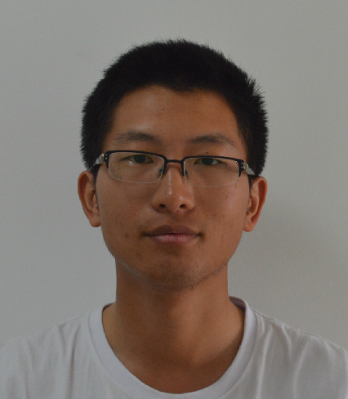**Name:** Cheng Hu

**Gender:** Male

**Data of Birth:** 15 March 1989

**Place of Birth:** Wuhan, Hubei, China

**Apartment Address:** 609 TurnerSt. Apt F

College Station, TX 77840

**Business Address:** 2123 tamu, borlaug center, Rm 151

College Station, TX 77843

**Work Phone:** 979-862-4801

**Mobile Phone:** 979-450-9011

**E-mail:** 819067856@qq.com

**Education**

Sept, 2011- June, 2015 China Agricultural University

Master, majored in Crops Genetics and Breeding

Sept, 2007- June, 2011 China Agricultural University

Bachelor, majored in Bio-Science

**Work Experience**

Oct, 2014- present Texas A&M University, Department of Plant Pathology and Microbiology

Research Scholar

**Awards and Group Memberships**

2012-2013 National Scholarship, China

**Publications**

[1] QingZhi Liang, **Cheng Hu**, Hua Hua, ZhaoHu Li, JinPing Hua. 2013. Construction of a linkage map and QTL mapping for fiber qualitytraits in upland cotton(*Gossypiumhirsutum* L.).*Chinese Science Bulletin*, Volume 58, Issue 26, pp 3233-3243

[2] QingZhi Liang, Pengbo Li, **Cheng Hu**, HuaHua, Zhaohu Li, YihuaRong, Kunbo Wang and Jinping Hua. 2013. Dynamic QTL and epistasis analysis for seedling root traits in upland cotton. *Journal of Genetics*.Volume 93, 63-78